ST10123828 A.S PHEWA
PDANA8412 Part 2 Report

Table of Contents
Executive Summary 3
1.Introduction, research question and client context 4
1.1 Continuity with Part 1 4
1.2 Problem statement and measurable outcome 4
1.3 Objectives 4
1.4 Why logistic regression? 4
2. Dataset suitability and quality 5
3. Analysis plan and experimental controls 6
3.1 Split and reproducibility 7
3.2 Evaluation criteria 7
4. Exploratory Data Analysis: price and market categories 8
5. Exploratory Data Analysis: content and publication date 10
5.1 Market indicators excluded from predictive features 12
5.2 Quality findings informing model design 13
6. Predictor construction and leakage prevention 13
6.1 Data transformation and mathematical model 13
6.2 Loss, gradients and learning updates 14
7. From-scratch model training and convergence 14
7.1 Numerical and implementation checks 15
7.2 Why model improvement is needed 15
8. Model improvement and validation-based selection 16
9. Final held-out evaluation 18
10. Business interpretation, further diagnostics and limits 20
10.1 Practical recommendations 21
10.2 Limitations 21
10.3 Additional prediction diagnostics 21
11. Conclusion 24
References 25

Table of Figures
Figure 1: Original bestseller class imbalance. 7
Figure 2: Missing entries in original Kindle data 8
Figure 3: Distribution of Kinlde listing prices 10
Figure 4: Within-class price comparison 10
Figure 5:Category-specific positive rates 11
Figure 6: Absolute bestseller counts by category 11
Figure 7: Length of book titles by outcome 12
Figure 8: Publication years where observed. 12
Figure 9: Publication-date missingness by label 13
Figure 10: Bestseller incidence 13
Figure 11:Review counts 14
Figure 12:Editorial recognition flags 14
Figure 13: Training losses for scratch implementations 16
Figure 14: Training convergence and validation monitoring 17
Figure 15: Validation F1 across scratch model configurations 18
Figure 16: How threshold choice changes F1 19
Figure 17: Validation ROC curves 19
Figure 18: Validation precision-recall curves 20
Figure 19: Final test confusion matrix 21
Figure 20: Final test precision-recall curve 21
Figure 21: Test reliability diagnostic 22
Figure 22: Descriptive precision in highest-scoring test groups 23
Figure 23: Final test ROC curve 24
Figure 24: Ranking performance under extreme imbalance 24
Figure 25: Largest signed coefficients in the model 25
Figure 26: Test-set predicted-score distributions 25

Table of Tables
Table 1: Dataset screening based on outcome validity and model suitability; unverified alternative record counts are intentionally not reported. 7
Table 2: Analysis Plan 8
Table 3: Feature inclusion and exclusion based on the intended decision and leakage risk. 15
Table 4: Actual validation results for the three from-scratch configurations. 18
Table 5: Final untouched-test model performance. 20

Executive Summary
This report evaluates whether a logistic regression classifier written from scratch can identify bestseller-labelled books for the same fictional publishing company considered in Part 1. Unlike the TextAge authorship task, this problem requires binary labels and book-market attributes. The selected Amazon Kindle Books 2023 dataset comprises 133,102 listings and 16 original variables. Of these, 2,236 (1.68%) are labelled as bestsellers; the minority prevalence determines the design of both the classifier and its evaluation (asaniczka, 2023; He and Garcia, 2009).
The dataset contains a real binary isBestSeller indicator, avoiding the need to invent bestseller thresholds from review counts. Nevertheless, it provides a cross-sectional market snapshot rather than a confirmed publication-time outcome; the results should therefore be described as bestseller-status classification, not validated future sales forecasting. Variables that could reflect commercial success after publication, including review counts, ratings and editorial honours, were withheld from training to reduce obvious leakage.
An original NumPy batch-gradient-descent implementation was tested with finite-difference gradient checking and fitted using a stratified 70:15:15 train/validation/test split. Training-set preprocessing combined numerical imputation, standardisation and one-hot encoding. Three models were compared: an unweighted baseline, a class-weighted configuration and a class-weighted configuration with L2 regularisation. Configuration and threshold selection relied exclusively on validation results; the held-out test labels were examined once afterwards (Pedregosa et al., 2011).
The chosen Balanced + L2 classifier used a validation-selected threshold of 0.72. On 19,966 untouched test listings, ROC-AUC was 0.778, average precision 0.058, precision 6.0%, recall 29.5%, and positive-class F1 0.100. It identified 99 of 336 observed bestseller listings but also produced 1,549 false positives. A majority-only rule would achieve 98.3% accuracy, exceeding the selected model’s 91.1%, illustrating why accuracy must not dominate rare-event evaluation (Saito and Rehmsmeier, 2015).
The classifier demonstrates a valid from-scratch implementation and useful ranking signal, but it is not commercially reliable for automatic advertising or acquisition decisions. It is more defensible as an interpretable experimental baseline and as evidence that the publisher needs genuine time-stamped, pre-release book descriptors and post-release sales outcomes.

1.Introduction, research question and client context

1.1 Continuity with Part 1
The fictional book press in Part 1 requested a fan-facing author-identification model trained on text passages using LSTM and BiLSTM architectures. Part 2 concerns a separate commercial decision: identifying which books display bestseller status. The same organisational scenario is retained, but a new dataset is appropriate because the TextAge corpus does not supply reliable bestseller outcomes. Page 4 of the PoE explicitly permits the selection of a different dataset for each task (IIE, 2026).

1.2 Problem statement and measurable outcome
The analytical question is: To what extent can book listing attributes distinguish books carrying an Amazon Kindle bestseller flag from other Kindle books in the 2023 snapshot? The binary response is isBestSeller, coded 1 where the dataset states True and 0 where it states False. The model outputs a continuous score between zero and one, and a threshold converts that score into a label. The selected label is not equivalent to sales revenue or to becoming a bestseller within a future time horizon.

1.3 Objectives
- Inspect the source, target definition and data-quality risks before modelling.
- Conduct reproducible exploratory analysis and report relationships relevant to predictor selection.
- Develop logistic regression by implementing the sigmoid, binary cross-entropy, gradients and parameter updates directly in NumPy.
- Use validation data to test class weighting, L2 regularisation and threshold selection, then assess the selected model once on untouched test data.
- Translate model errors into cautious, evidence-based recommendations for the publisher.

1.4 Why logistic regression?
Logistic regression is an interpretable binary probabilistic classification approach. Its linear score can be combined with a sigmoid transformation, fitted by gradient descent, and evaluated using class-sensitive diagnostic measures. The rarity of the positive outcome requires explicit consideration of class weights, decision thresholds and the relationship between ROC curves and precision–recall curves (King and Zeng, 2001; Fawcett, 2006; Saito and Rehmsmeier, 2015).

2. Dataset suitability and quality
The selected source is asaniczka (2023), Amazon Kindle Books Dataset 2023 – 130K Books. The actual CSV contains 133,102 listings, 16 original columns, an existing boolean isBestSeller target and book descriptors such as category, price, title, Kindle Unlimited status and publication date. Direct market metadata offer meaningful class comparisons without deriving success from arbitrary rating cut-offs (asaniczka, 2023).
Table 1: Dataset screening based on outcome validity and model suitability; unverified alternative record counts are intentionally not reported.
Candidate | Strength | Key drawback
Amazon Kindle 2023 (selected) | 133,102 records; explicit isBestSeller flag; book descriptors | Snapshot label provenance, publication timing and market transfer limitations
Goodreads-style book data | Extensive title, rating and author metadata | Ratings/popularity do not establish an independent bestseller outcome
Book-Crossing interactions | Reader–book ratings useful for preferences | No verified comparable bestseller target without external matching

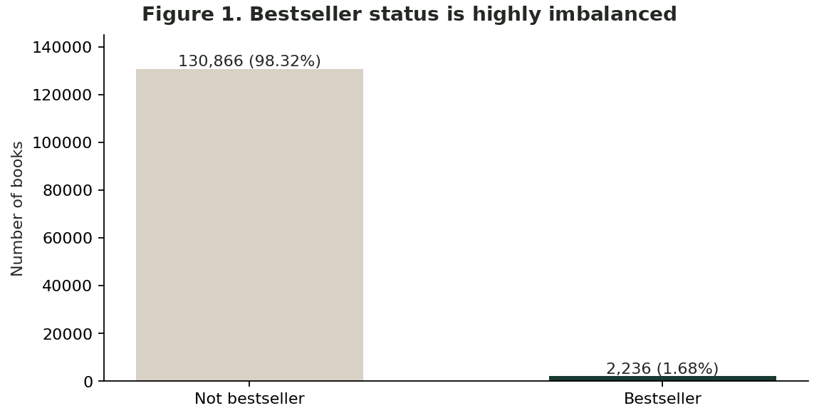
Figure 1: Original bestseller class imbalance.
Interpretation. Only 2,236 of 133,102 books (1.68%) are positive. An all-negative prediction rule would already appear highly accurate, so precision, recall and F1 are essential.

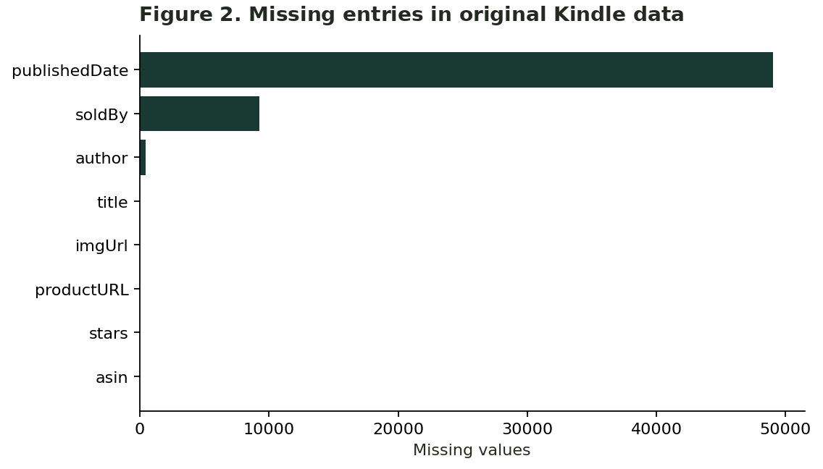
Figure 2: Missing entries in original Kindle data
Interpretation. Publication date is absent for 49,016 records (36.83%); seller and author are also incomplete. The date must be imputed only after data splitting.
No duplicate ASINs or fully duplicated rows were found in the original dataset. The target values are present and boolean. Missing dates, uncertain extraction-date provenance, imperfect evidence of author/seller consistency and large category differences were treated as quality concerns rather than silently corrected.

3. Analysis plan and experimental controls
The workflow below was designed to make each modelling choice auditable. The separation of validation and test partitions is especially important because threshold tuning after seeing test outcomes would bias the final estimate (Pedregosa et al., 2011).
Table 2: Analysis Plan
Phase | Procedure | Control and evidence
Dataset assessment | Confirm provenance, 10,000+ observations, target and null counts | Reject invented labels and inspect target reliability
Spark/EDA | Spark read, schema, grouped null/label summaries; pandas visualisations | Preserve Spark execution evidence, assess patterns and imbalance
Cleaning | Retain ASIN-unique records; parse valid dates; handle invalid prices | Document transformations and treatment of missing values
Feature selection | Review timing of signals; retain price, category, title length, year and KU status | Exclude potentially post-success ratings/reviews/badges
Partition | Stratified 70% training / 15% validation / 15% test | Never fit an imputer or scaler before splitting
Train | Implement weights, sigmoid, BCE, gradient descent, L2 manually | Finite-difference check for analytical gradient
Improve | Compare unweighted, weighted and weighted+L2 models | Select threshold/configuration by validation F1
Final evaluation | Once on test: precision, recall, F1, ROC-AUC, AP, confusion matrix | Evaluate operational errors against 98.3% majority accuracy
Report | Explain findings, limitations, transferability and further data needs | Link each figure to a justified modelling or business decision

3.1 Split and reproducibility
The seed was fixed at 42. The actual stratified split contains 93,171 training, 19,965 validation and 19,966 test records. Each subset maintains close to the 1.68% bestseller prevalence. The fitting operation for median imputation, standard scaling and categorical one-hot encoding uses only the training partition; the trained transformation is then applied unchanged to validation and test observations.

3.2 Evaluation criteria
A rare-positive problem makes raw accuracy misleading. Precision quantifies the share of predicted bestsellers that are truly labelled as such; recall measures the proportion of observed bestsellers found; F1 balances the two. ROC-AUC describes pairwise ranking, whereas average precision summarises positive-class retrieval and is sensitive to very low prevalence (He and Garcia, 2009; Saito and Rehmsmeier, 2015).

4. Exploratory Data Analysis: price and market categories
Figures 3 and 4 connect descriptive market patterns to the feature-selection plan. All comparisons are derived from the original observed records; they do not imply that adjusting price or category would cause bestseller status.
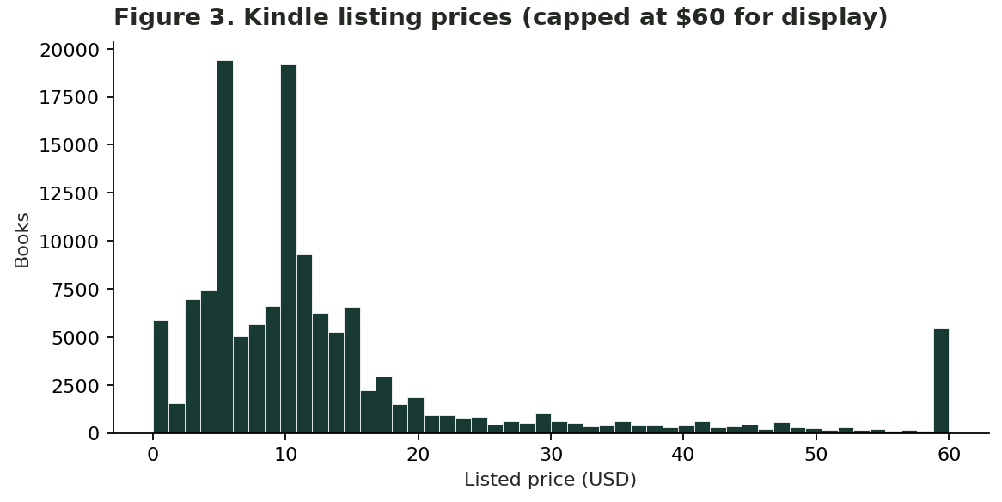
Figure 3: Distribution of Kinlde listing prices
Interpretation. Prices concentrate in the lower range. The plot caps values at US$60 for visibility rather than discarding outliers from the dataset.
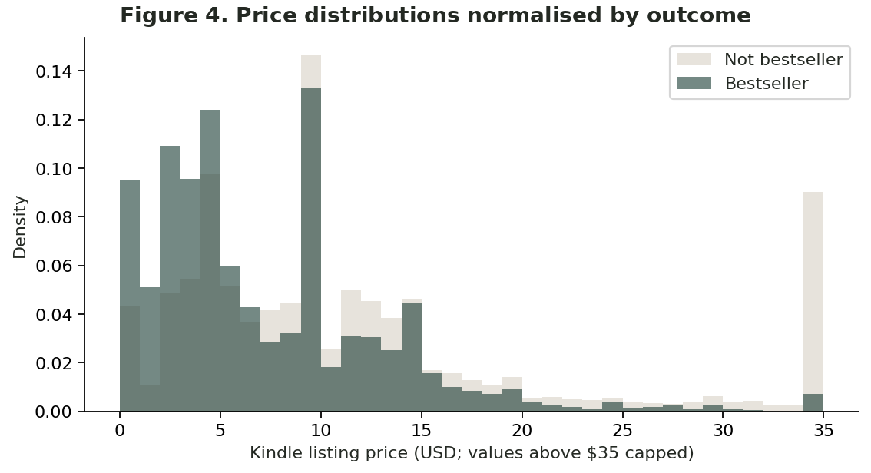
Figure 4: Within-class price comparison

Interpretation. The median listed price is US$9.99 for non-bestsellers and US$5.99 for bestsellers. Overlap remains substantial; price alone is not a reliable label.
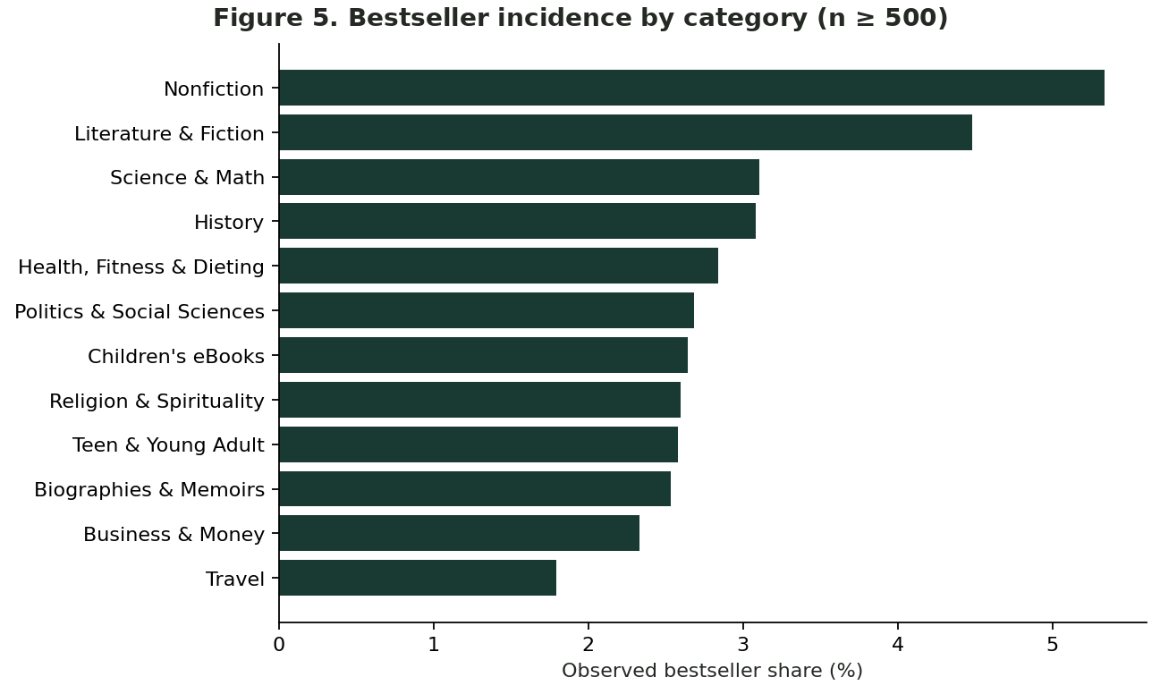
Figure 5:Category-specific positive rates
Interpretation. Rates differ between categories when at least 500 listings are present, making category a meaningful candidate predictor but not a causal driver.
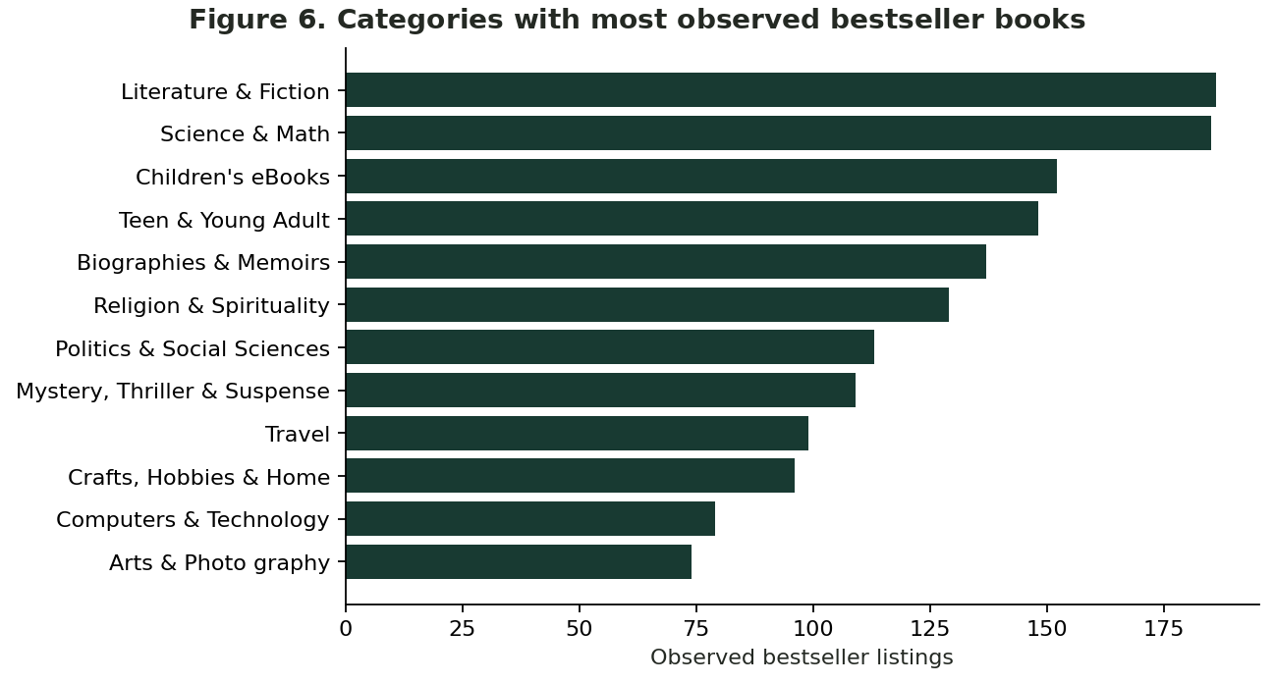
Figure 6: Absolute bestseller counts by category
Interpretation. Counts depend heavily on category size, so categories with many flagged books need not have the highest within-category likelihood.
This contrast demonstrates why percentage denominators matter. Treating the largest raw bestseller category as the best commercial opportunity would confuse catalogue volume with success rate. Category is one-hot encoded, while the high-cardinality category name is not converted into arbitrary ordinal integers.

5. Exploratory Data Analysis: content and publication date
Content and date descriptors were retained only where their timing and missingness were judged interpretable. Model implementation uses title word count, not free-form title text; the former is a compact length descriptor rather than a substitute for a full natural-language model.
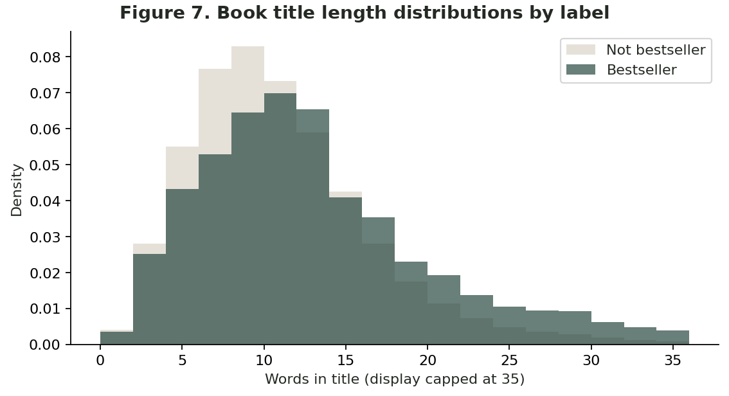
Figure 7: Length of book titles by outcome
Interpretation. Bestseller-labelled books have longer titles on average (12.49 words against 10.47). The distributions overlap, so the effect should not be overinterpreted.
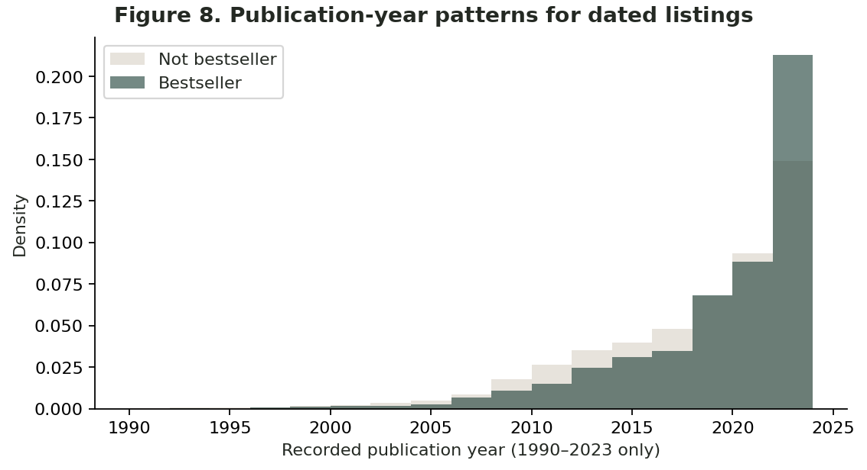
Figure 8: Publication years where observed.
Interpretation. This conditional plot excludes undated records. It describes only the dated subset and cannot support a historical forecasting claim.
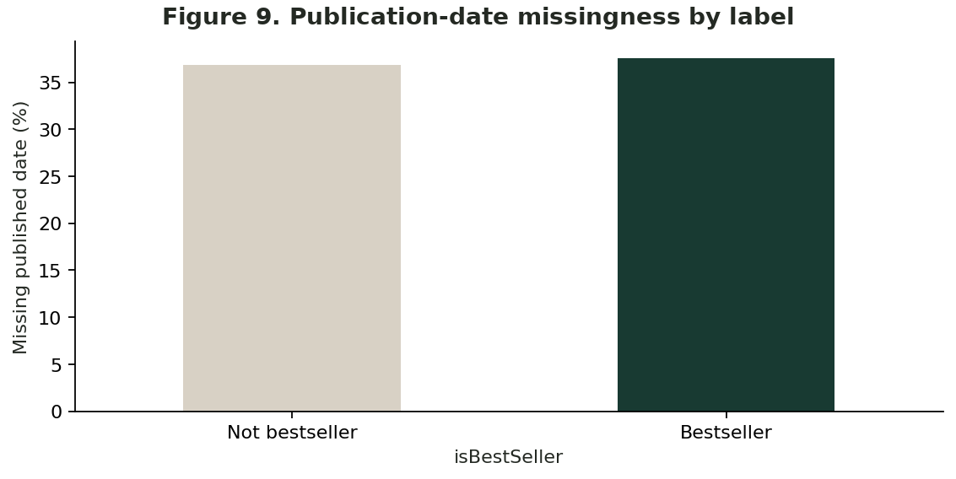
Figure 9: Publication-date missingness by label
Interpretation. Missing publication dates occur in 36.81% of negative cases and 37.52% of positive cases, so missingness is widespread rather than confined to one class.
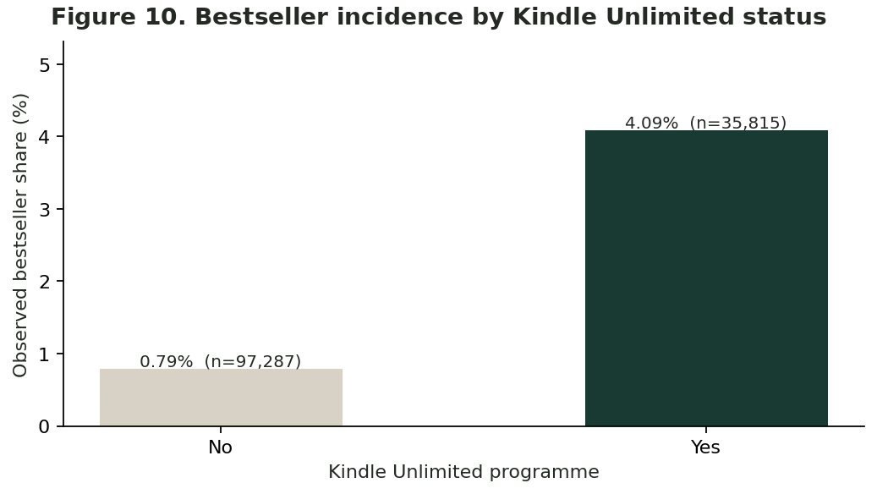
Figure 10: Bestseller incidence
Interpretation. Observed bestseller rates are approximately 0.79% without Kindle Unlimited and 4.09% with it; programme membership may not have preceded success.
A numerical publication-year value was parsed with invalid or out-of-range entries marked missing, then filled with a training-only median and an indicator. Kindle Unlimited membership was encoded as a categorical value. Because listing status may change over a title’s life, the latter is exploratory association rather than a verified pre-publication predictor.

5.1 Market indicators excluded from predictive features
High review counts, editorial badges and ratings might correlate with bestseller status precisely because they are accumulated or assigned after a book succeeds. Their inclusion in a supposed forward-looking tool risks temporal leakage and misleadingly strong assessment results. The notebook therefore analyses but does not train on stars, reviews, Editor’s Pick or Goodreads Choice flags.
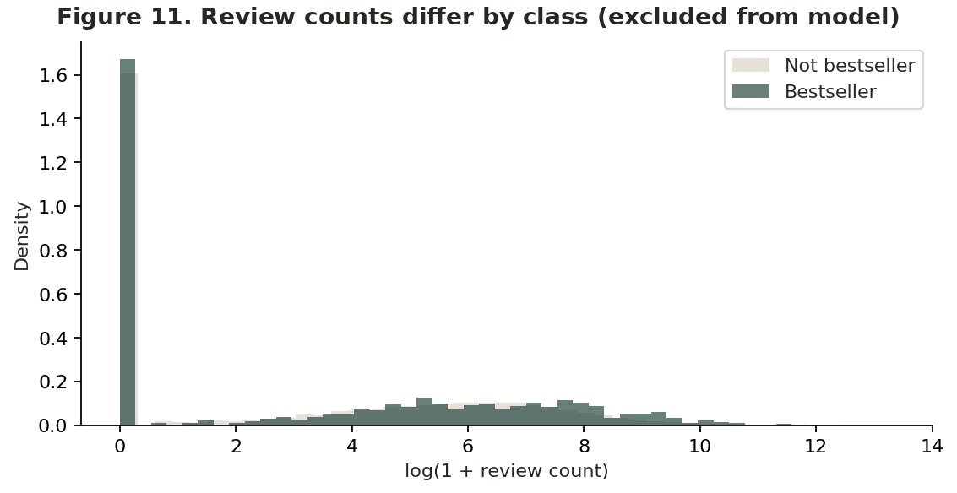
Figure 11:Review counts
Interpretation. Median reviews are 30 for the bestseller group and 4 for other books. This observed association could reflect sales activity after success and is therefore not used as a predictor.
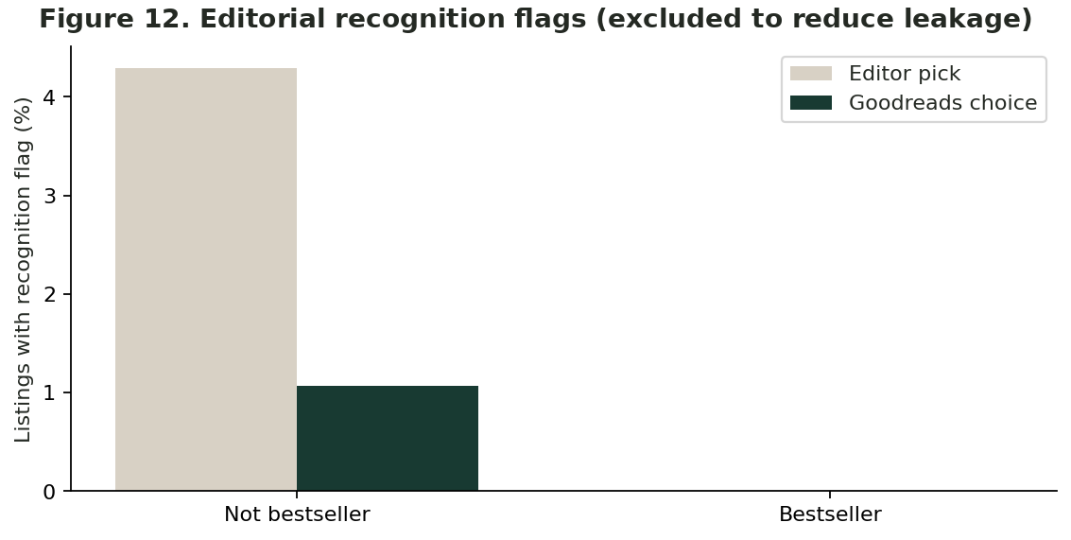
Figure 12:Editorial recognition flags
Interpretation. In the supplied CSV neither recognition indicator is True for the bestseller-labelled rows. This potentially artefactual pattern reinforces caution rather than validating a predictive signal.

5.2 Quality findings informing model design
The analysis identified several common pitfalls: extreme base-rate imbalance; missing historical dates; prices recorded at one time rather than frozen at publication; lack of verified sales totals; and categorical variability. The 1.68% positive class motivates weighted-loss experiments. Training-only imputation limits leakage from summary statistics. Excluding reviews and honours removes some obvious hindsight indicators, but cannot eliminate all time-dependent bias from the snapshot itself.

6. Predictor construction and leakage prevention
A deliberately restrained predictor set was chosen to reflect book listing descriptors while avoiding direct reviews and awards. Price and Kindle Unlimited status are still snapshot observations and may change; they should not be interpreted as genuine publication-time covariates without dated provenance.
Table 3: Feature inclusion and exclusion based on the intended decision and leakage risk.
Status | Fields | Rationale
Retained | price; title_word_count; published_year | Numeric market and title descriptors; year median-imputed with indicator
Retained | category_name; isKindleUnlimited | Categorical variables one-hot encoded using training categories
Excluded | reviews; stars; isEditorsPick; isGoodReadsChoice | Potential post-success/hindsight information
Excluded | asin; imgUrl; productURL; category_id | Identifiers, URLs or duplicate category coding
Excluded | author; soldBy | High cardinality and uncertain availability at prediction time

6.1 Data transformation and mathematical model
The numeric pipeline applies median imputation with missingness indicators and standard scaling. The categorical pipeline applies most-frequent imputation and one-hot encoding with unseen categories ignored. Both are fitted on the training data. The model uses the linear score z = Xw + b and converts it into a binary probability score with the sigmoid σ(z) = 1 / (1 + exp(−z)). A decision threshold determines the final binary prediction (Hastie, Tibshirani and Friedman, 2009).

6.2 Loss, gradients and learning updates
Binary cross-entropy penalises confident incorrect predictions: L = mean[log(1 + exp(z)) − yz], computed with a numerically stable logaddexp operation. Class weighting replaces the unweighted mean with a weighted average, and optional L2 regularisation adds λ‖w‖²/2. The gradients are based on Xᵀ(s ⊙ (p − y))/Σs + λw for the weights and the corresponding weighted residual mean for the bias. Batch gradient descent applies w ← w − η∇wL and b ← b − η∇bL.
The implementation starts with zero-valued coefficients, supports a learning rate and number of epochs, and saves loss histories. It uses NumPy for all optimisation calculations and SciPy only for the stable sigmoid evaluation; it does not fit Scikit-learn LogisticRegression. A finite-difference numerical gradient comparison passed, providing a targeted correctness check beyond apparent convergence.

7. From-scratch model training and convergence
Three configurations were trained with the same split and feature transform. The baseline used no class weights, a learning rate of 0.20 and 240 epochs; the weighted model used inverse-frequency class weights with the same learning rate and iterations; the L2 model added λ = 0.005 and ran for 280 epochs. The models use full-batch gradient descent. The computational design is reproducible, although these choices are an exploratory parameter comparison, not a comprehensive search of all possible configurations.
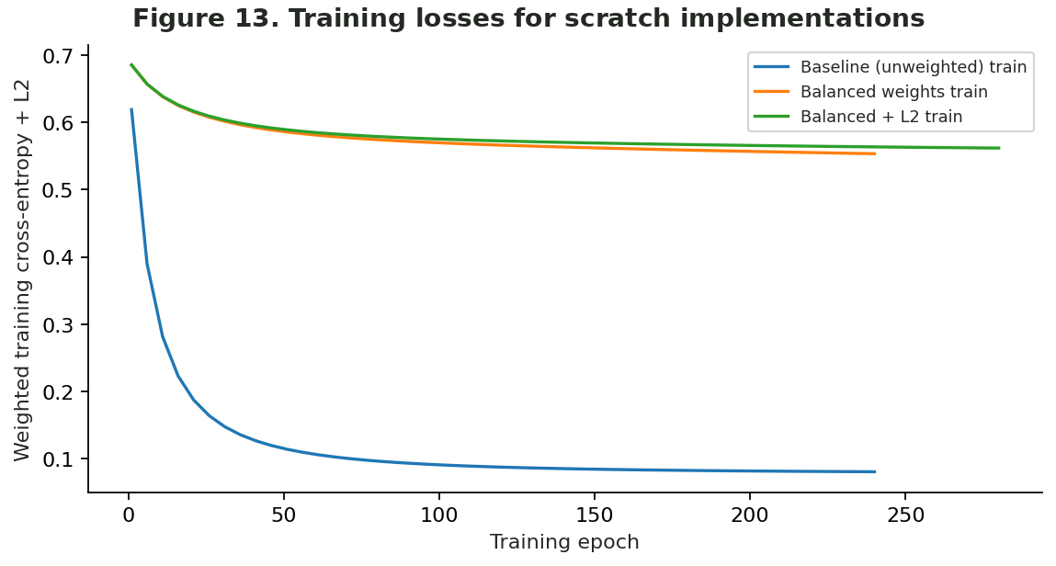
Figure 13: Training losses for scratch implementations
Interpretation. All three versions show a decreasing objective. Their numerical loss values cannot be interpreted identically because weighting and L2 change the objective function.

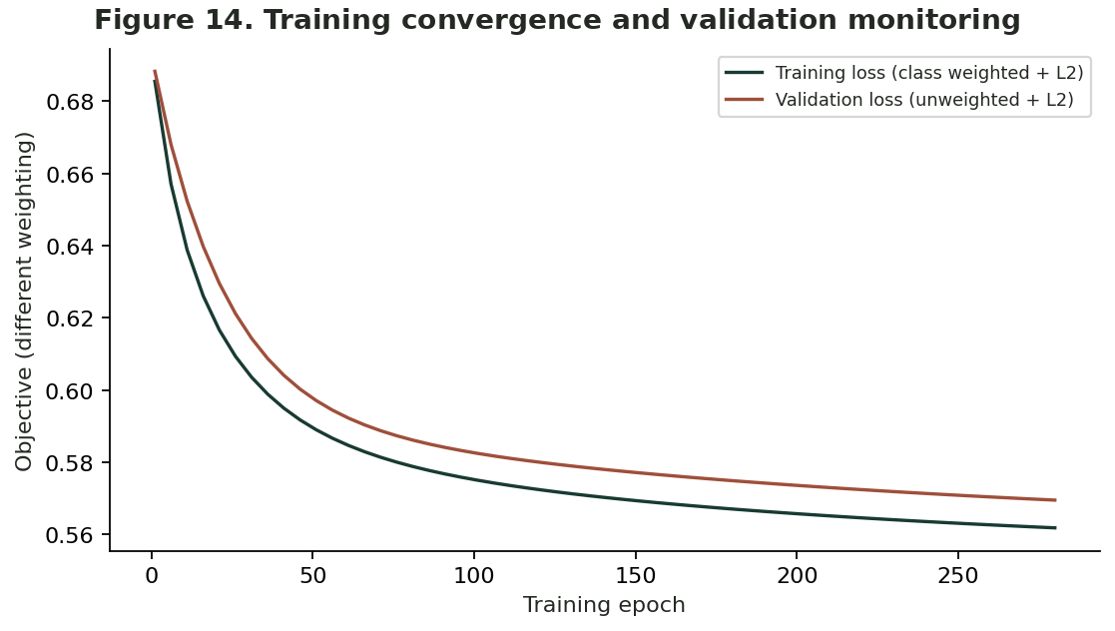
Figure 14: Training convergence and validation monitoring
Interpretation. Monitoring shows convergence; training uses weighted loss and validation uses unweighted loss, so the two levels are not directly equivalent.

7.1 Numerical and implementation checks
The executed notebook confirms that the engineered arrays are finite and have compatible training, validation and test dimensions. The analytical gradient of a small random numerical example matched the finite-difference approximation within tolerance. The sigmoid and log-loss implementations use stable functions to avoid overflow for extreme linear scores. This provides evidence that the primary algorithm was actually built and trained rather than delegated to a ready-made classifier.

7.2 Why model improvement is needed
With only 1.68% positive examples, minimising an ordinary average loss can favour negative predictions. Inverse-frequency weighting increases the influence of the minority class, while L2 discourages excessively large coefficients. Such strategies may increase recall at the cost of more false positives; the impact must therefore be assessed through validation F1 and precision–recall analysis rather than accuracy alone (King and Zeng, 2001; He and Garcia, 2009).

8. Model improvement and validation-based selection
All candidate thresholds were evaluated on the validation portion only, using a 0.05–0.95 grid. The best configuration was selected by validation positive-class F1, with average precision as a secondary comparison. The final test set did not influence this decision.
Table 4: Actual validation results for the three from-scratch configurations.
Model | Threshold | Precision | Recall | F1 | ROC-AUC | AP
Balanced + L2 | 0.72 | 0.064 | 0.322 | 0.107 | 0.773 | 0.054
Balanced weights | 0.74 | 0.065 | 0.293 | 0.106 | 0.771 | 0.054
Baseline (unweighted) | 0.05 | 0.064 | 0.215 | 0.099 | 0.730 | 0.046

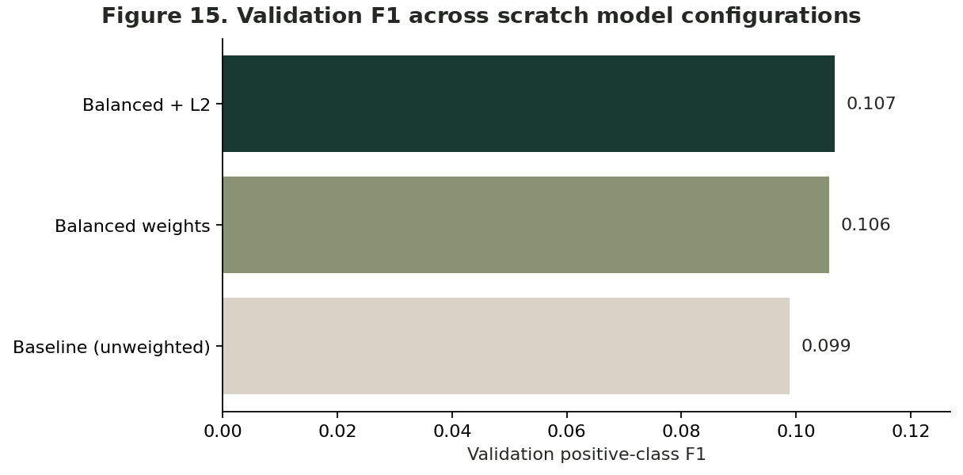
Figure 15: Validation F1 across scratch model configurations

Interpretation. Weighted regularised logistic regression achieved the highest validation F1 (0.1067), only marginally ahead of balanced weighting (0.1058).
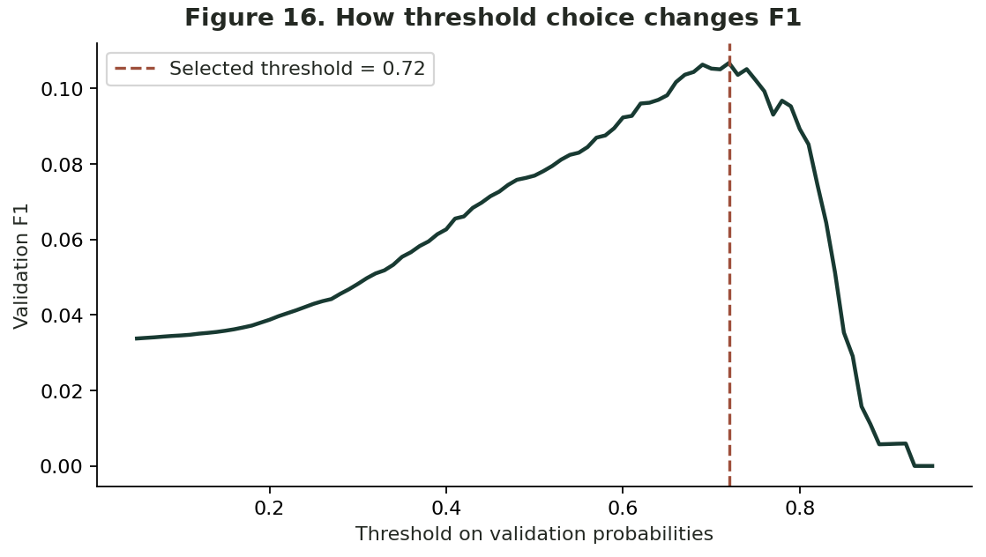
Figure 16: How threshold choice changes F1
Interpretation. The winning threshold of 0.72 was selected before test evaluation. This non-default cut-off illustrates that a 0.50 rule need not maximise F1.
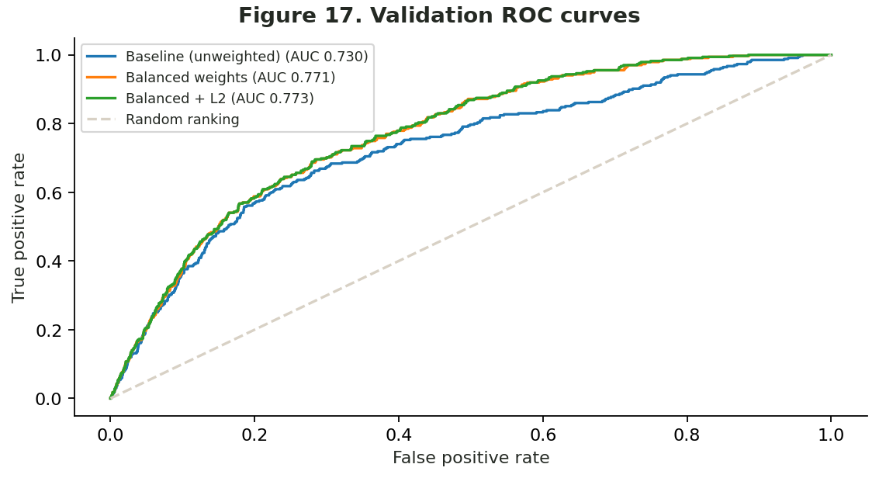
Figure 17: Validation ROC curves
Interpretation. The class-weighted variants rank labels better than the baseline, but ROC-AUC does not reveal how few flagged titles are truly positive.
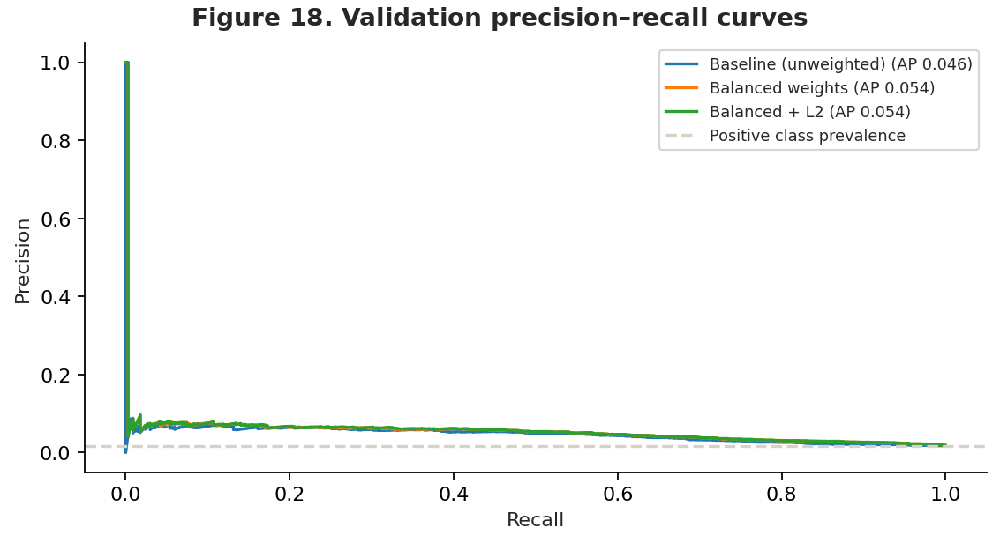
Figure 18: Validation precision-recall curves
Interpretation. Average precision of approximately 0.054 for the selected model remains low in absolute terms despite exceeding the positive rate.

9. Final held-out evaluation
The chosen model, Balanced + L2, used the validation threshold 0.72 and was evaluated exactly once on 19,966 test listings, including 336 labelled bestsellers. The following are measured outputs, not estimated future sales results.
Table 5: Final untouched-test model performance.
Performance measure | Observed test value | Implication
Precision | 6.01% | Approximately 6 correctly labelled bestsellers per 100 positive flags
Recall | 29.46% | About 29% of observed bestsellers detected
Positive class F1 | 0.100 | Weak combined precision/recall
ROC-AUC | 0.778 | Some separation of positive and negative rankings
Average precision | 0.058 | Higher than 1.68% prevalence but still low
Accuracy | 91.05% | Below majority-only accuracy of 98.32%

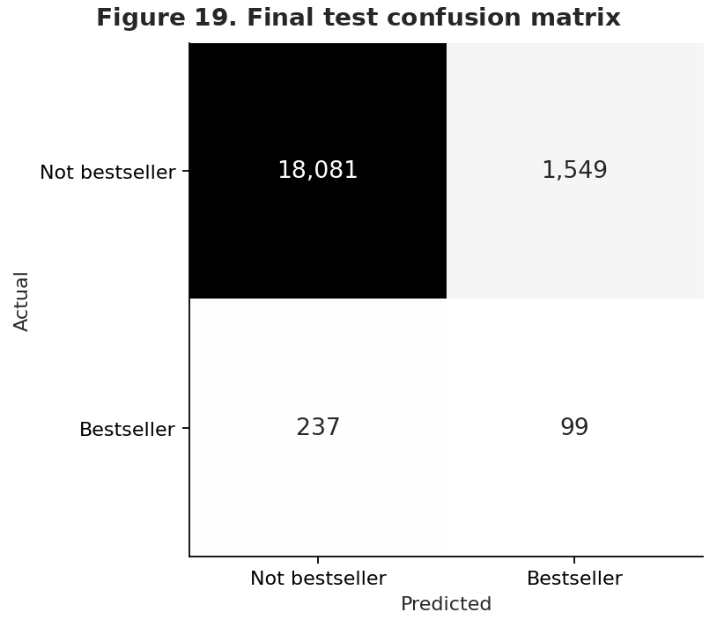
Figure 19: Final test confusion matrix
Interpretation. 99 true positives and 237 false negatives occur alongside 1,549 false positives and 18,081 true negatives. False marketing flags dominate correct positive flags.
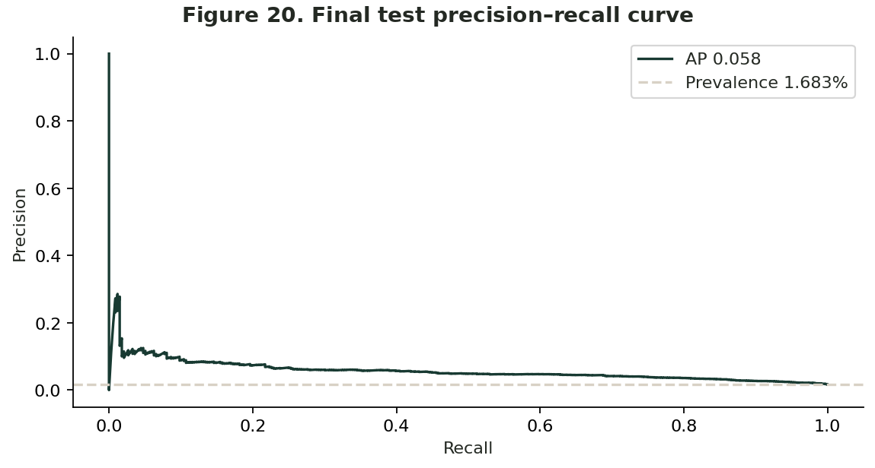
Figure 20: Final test precision-recall curve

Interpretation. 99 true positives and 237 false negatives occur alongside 1,549 false positives and 18,081 true negatives. False marketing flags dominate correct Interpretation. Average precision is 0.0575 compared with 0.0168 prevalence, but precision remains too low for automatic expenditure decisions.
Accuracy would mislead the client because predicting every book as a non-bestseller gives 98.32% test accuracy while finding no bestsellers. Equally, the test ROC-AUC of 0.778 should not be advertised as 77.8% accuracy. The AUC describes ranking comparisons and does not make the default score suitable for reliable probability or decision use (Fawcett, 2006; Saito and Rehmsmeier, 2015).

10. Business interpretation, further diagnostics and limits
Two errors matter commercially. A false positive might lead to scarce marketing resources being spent on a book without a bestseller label; a false negative could cause the publisher to overlook a title with commercial potential. Relative error costs were not supplied, so an economically optimal decision threshold cannot be claimed.
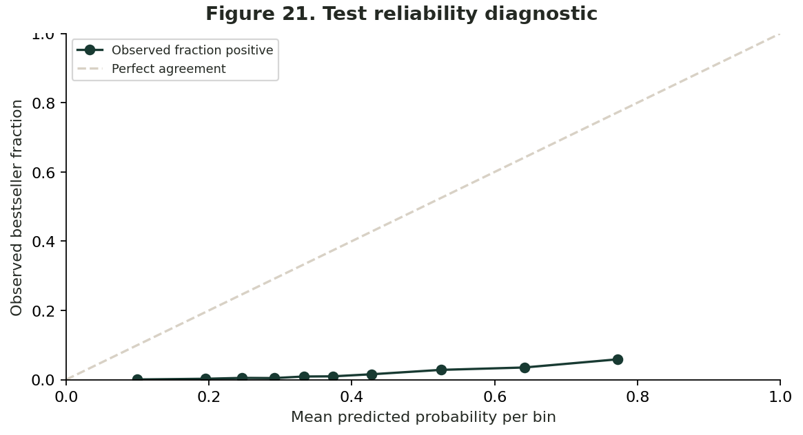
Figure 21: Test reliability diagnostic
Interpretation. The class-weighted model has substantial probability miscalibration. Scores should not be read literally as chances of becoming bestsellers without calibration and a future cohort.
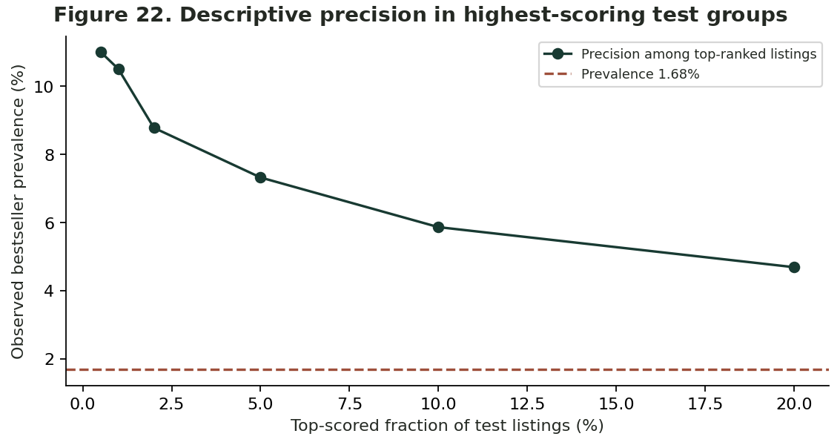
Figure 22: Descriptive precision in highest-scoring test groups

10.1 Practical recommendations
The publisher should use these findings as an exploratory screening study, not as a decision engine. Before deployment, it needs pre-release feature snapshots, clear outcome rules (for example, a specified sales-rank or unit-sales threshold over a declared time horizon), records from its own catalogue and distribution channels, and a prospective time-based evaluation. Business costs of false positives and negatives should inform the chosen decision threshold. Probability calibration and monitoring are also needed if users are expected to interpret scores quantitatively (Niculescu-Mizil and Caruana, 2005).

10.2 Limitations
The main limitations are (i) the unknown rule and observation date behind Amazon’s bestseller flag, (ii) inability to verify whether prices or subscription status preceded success, (iii) missing dates for over a third of records, (iv) one-platform scope, (v) positive-class prevalence below 2%, and (vi) a random test split rather than independent future book releases. Neither coefficient direction nor category association establishes causation.

10.3 Additional prediction diagnostics
The four additional diagnostics below complement the existing model evaluation. They are based on the same executed model outputs, and they should not be interpreted as evidence that the model forecasts future bestseller outcomes.
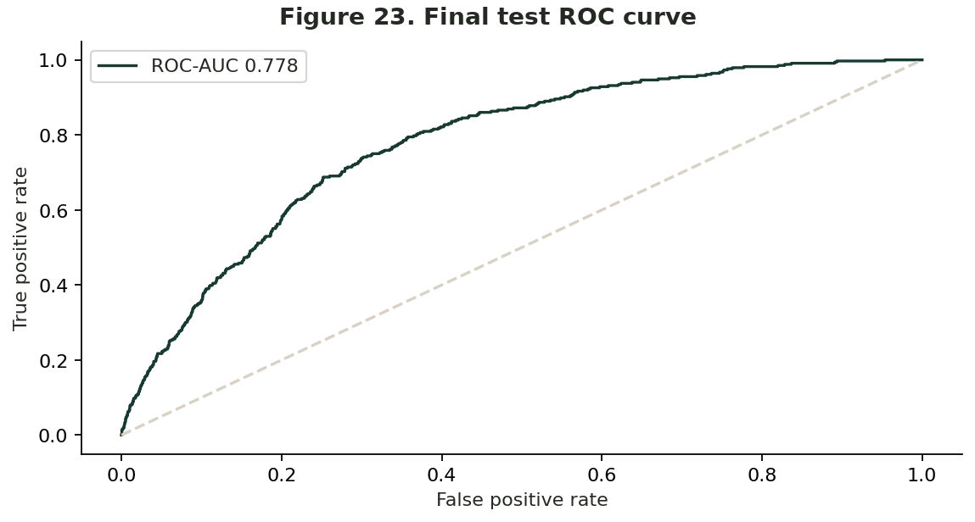
Figure 23: Final test ROC curve

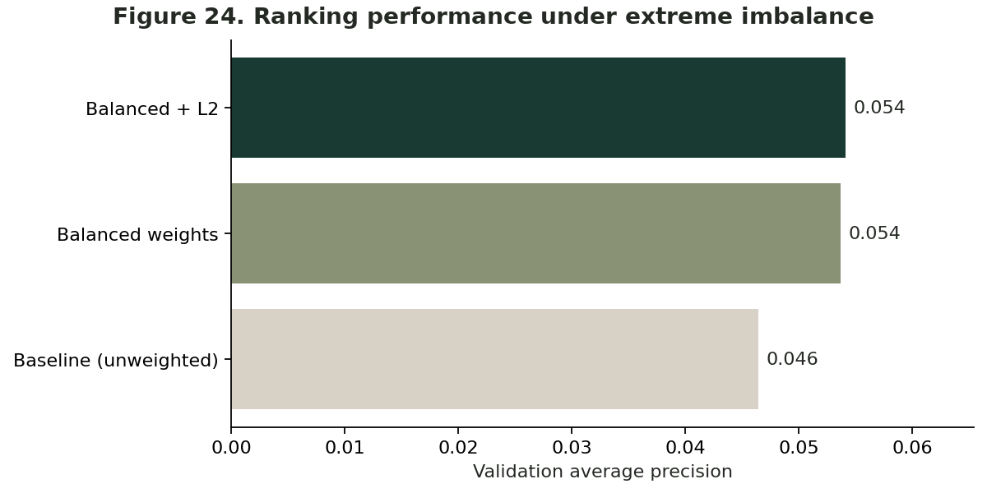
Figure 24: Ranking performance under extreme imbalance
Interpretation. Balanced + L2 had a validation average precision of 0.0541, versus 0.0537 for balanced weights and 0.0464 for the unweighted baseline. Although the selected model leads on this measure, the difference between weighted configurations is small, and all values remain modest in absolute terms.
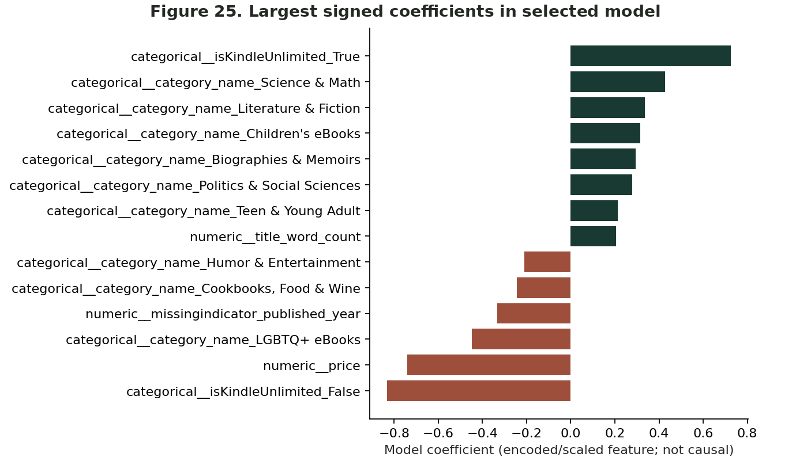
Figure 25: Largest signed coefficients in the model
Interpretation. Coefficients describe the direction and relative size of fitted associations on the model’s transformed feature scale, not causal effects. Group-specific one-hot coefficients depend on the reference categories, while snapshot variables such as price and Kindle Unlimited status require special timing caution.
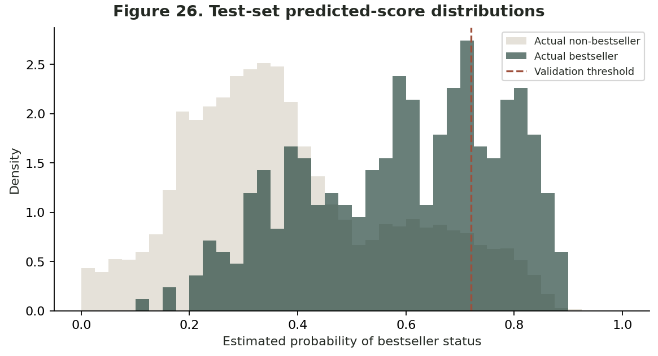
Figure 26: Test-set predicted-score distributions
Interpretation. The overlapping score distributions illustrate why even a model with useful ranking power produces a large number of false positive classifications. The validation-selected decision threshold of 0.72 changes the trade-off between false alarms and missed positives but does not solve the underlying base-rate problem.

11. Conclusion
This study investigated the application of a Logistic Regression algorithm developed from scratch to classify bestselling books using the Amazon Kindle Books dataset. The analysis demonstrated how statistical modelling and machine learning techniques can be applied to publishing data to identify relationships between book characteristics and commercial performance. Through systematic data preparation, feature selection, model training and evaluation, the study established a structured approach to addressing the classification problem. The findings also highlighted the importance of considering data quality, class distribution and appropriate performance measures when developing predictive models.
The final model achieved a ROC-AUC score of approximately 0.78, indicating a reasonable ability to distinguish between bestselling and non-bestselling books. However, its relatively low precision demonstrated that identifying successful titles remains challenging, particularly because bestsellers represent a small proportion of the dataset. These findings suggest that although Logistic Regression provides an interpretable foundation for classification, its predictions should not be relied upon as the sole basis for publishing decisions.
Overall, the study demonstrates the potential value of data-driven approaches in supporting publishing strategies while recognizing the limitations of the available data and model performance. Future research could incorporate historical sales information, marketing expenditure, author popularity and additional predictive techniques to improve classification reliability. Such developments would provide a stronger basis for evaluating the commercial potential of books and supporting more informed decisions within the publishing industry.

References
Apache Software Foundation. 2026. PySpark SQL DataFrameReader.csv documentation. [online] Available at: https://spark.apache.org/docs/latest/api/python/reference/pyspark.sql/api/pyspark.sql.DataFrameReader.csv.html [Accessed 13 October 2026].
Asaniczka. 2023. Amazon Kindle Books Dataset 2023 – 130K Books. [online dataset] Kaggle. Available at: https://www.kaggle.com/datasets/asaniczka/amazon-kindle-books-dataset-2023-130k-books [Accessed 13 October 2026].
Fawcett, T. 2006. An introduction to ROC analysis. Pattern Recognition Letters, [e-journal] 27(8), pp.861–874. doi: 10.1016/j.patrec.2005.10.010.
Hastie, T., Tibshirani, R. and Friedman, J. 2009. The elements of statistical learning: Data mining, inference, and prediction. 2nd ed. New York: Springer.
He, H. and Garcia, E.A. 2009. Learning from imbalanced data. IEEE Transactions on Knowledge and Data Engineering, [e-journal] 21(9), pp.1263–1284. doi: 10.1109/TKDE.2008.239.
King, G. and Zeng, L. 2001. Logistic regression in rare events data. Political Analysis, [e-journal] 9(2), pp.137–163. doi: 10.1093/oxfordjournals.pan.a004868.
Niculescu-Mizil, A. and Caruana, R. 2005. Predicting good probabilities with supervised learning. Proceedings of the 22nd International Conference on Machine Learning. Bonn, Germany, 7–11 August 2005. New York: Association for Computing Machinery, pp.625–632. doi: 10.1145/1102351.1102430.
Pedregosa, F., Varoquaux, G., Gramfort, A., Michel, V., Thirion, B., Grisel, O., Blondel, M., Prettenhofer, P., Weiss, R., Dubourg, V., Vanderplas, J., Passos, A., Cournapeau, D., Brucher, M., Perrot, M. and Duchesnay, É. 2011. Scikit-learn: Machine learning in Python. Journal of Machine Learning Research, [e-journal] 12(85), pp.2825–2830. Available at: https://jmlr.org/papers/v12/pedregosa11a.html [Accessed 13 October 2026].
Saito, T. and Rehmsmeier, M. 2015. The precision-recall plot is more informative than the ROC plot when evaluating binary classifiers on imbalanced datasets. PLOS ONE, [e-journal] 10(3), e0118432. doi: 10.1371/journal.pone.0118432.

